1. The two sets of photos down below are formatted to use Pixel 2XL, and one is in normal Pixel 2XL format while the second photo is in landscape format. Changes in the layout experience that could be changed to improve the user's experience is to position that name of the site. In the first image, it shows the Cryptozoology Repository, but the title is slanted to the right and instead should be positioned to the middle to show the full title. The second image that is shown shows the navigation, but the picture is too large that is being displayed.

1.

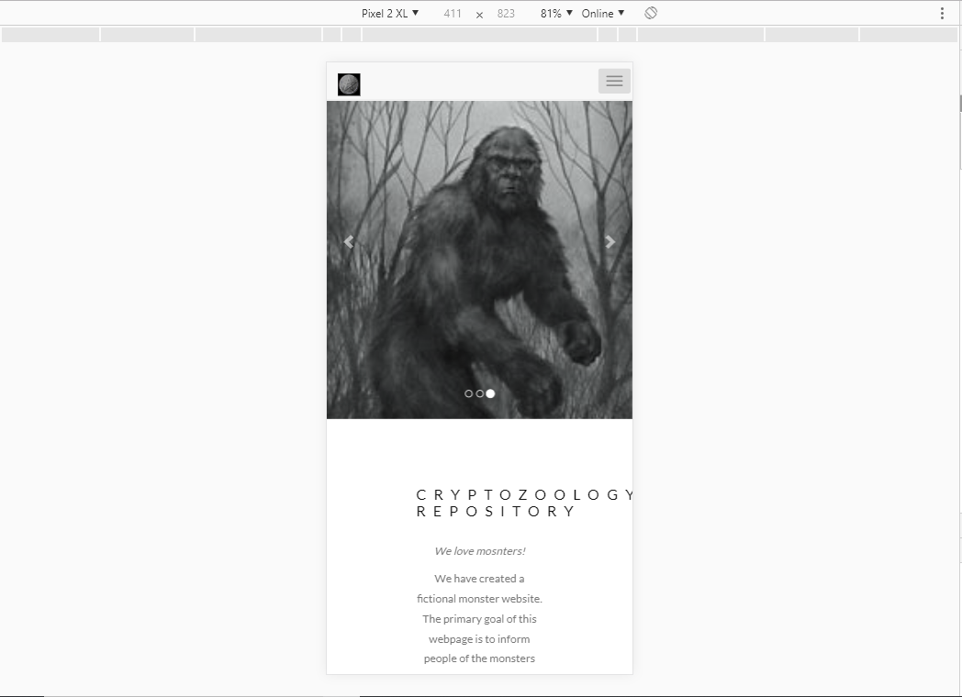

1.2

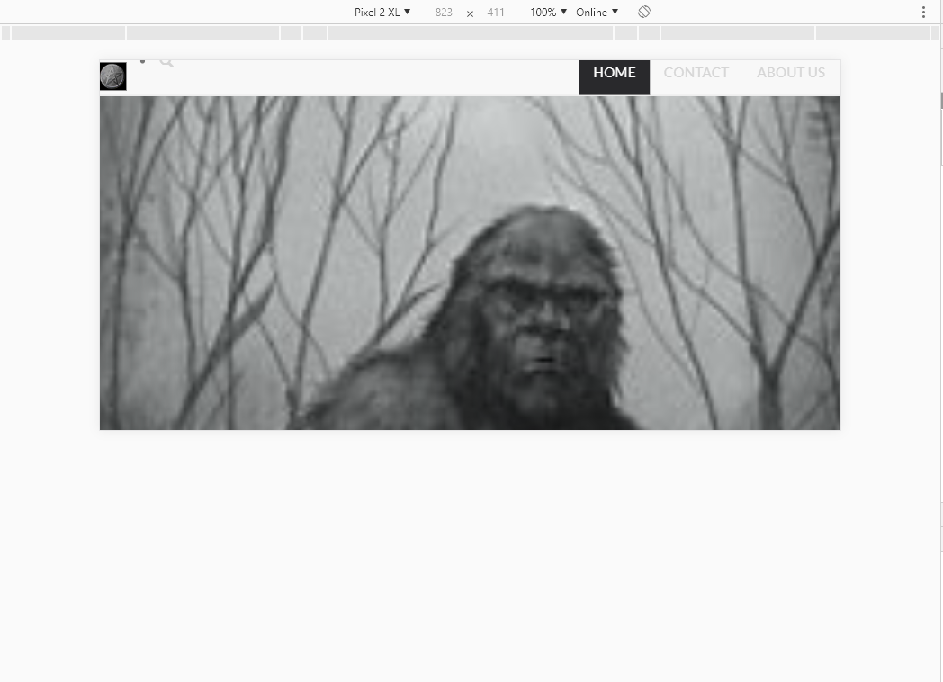

2. In the next set of images, the screen has been changed to Samsung Galaxy S5 to display the website. In the first image everything looks ok with the webpage, but the name of the page. The name Cryptozoology Repository is still slanted towards the right of the page not displaying the full name. In landscape format, the images and names are fully displayed throughout the webpage. 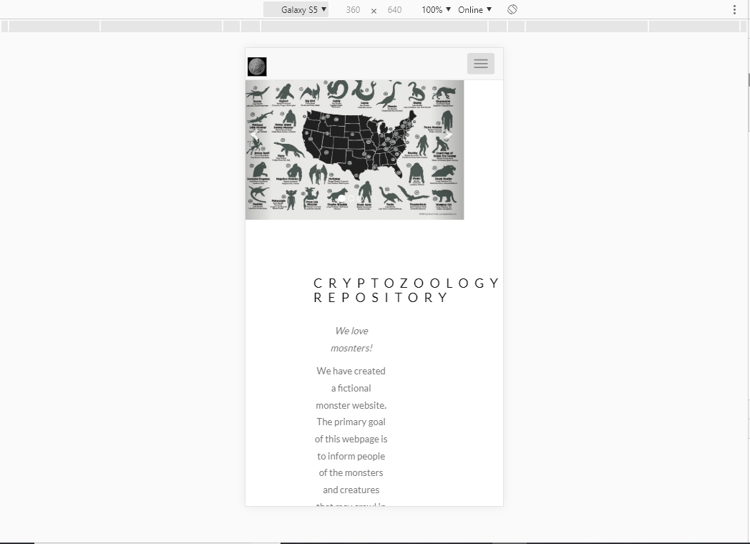

2.1

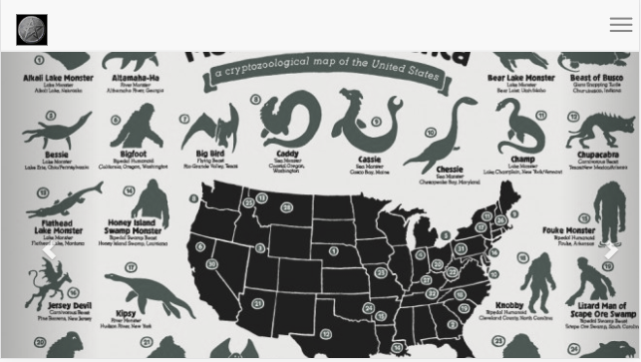

2.2

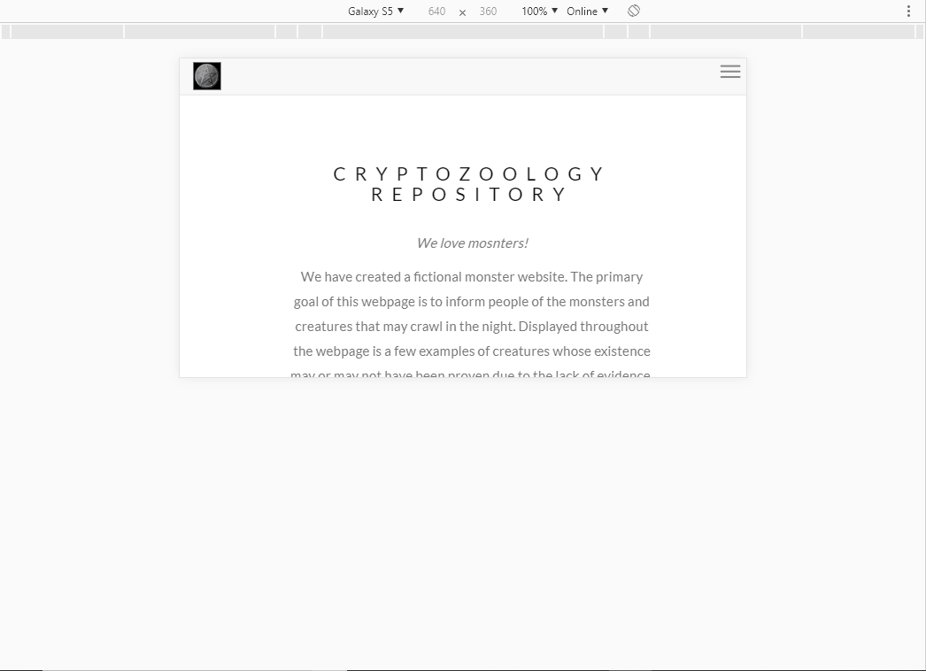

3. The next set of images show the webpage displayed in an iPhone X format and the change that needs to be made is the position of Cryptozoology Repository. The name Cryptozoology Repository is still slanted to the right and not showing the full title. Also changing the format to iPhone X also makes the words smaller compared to other formats such as Pixel 2XL, and Samsung Galaxy S5. When the webpage is in landscape format, the title can be fully shown and the words and pictures are displayed correctly.

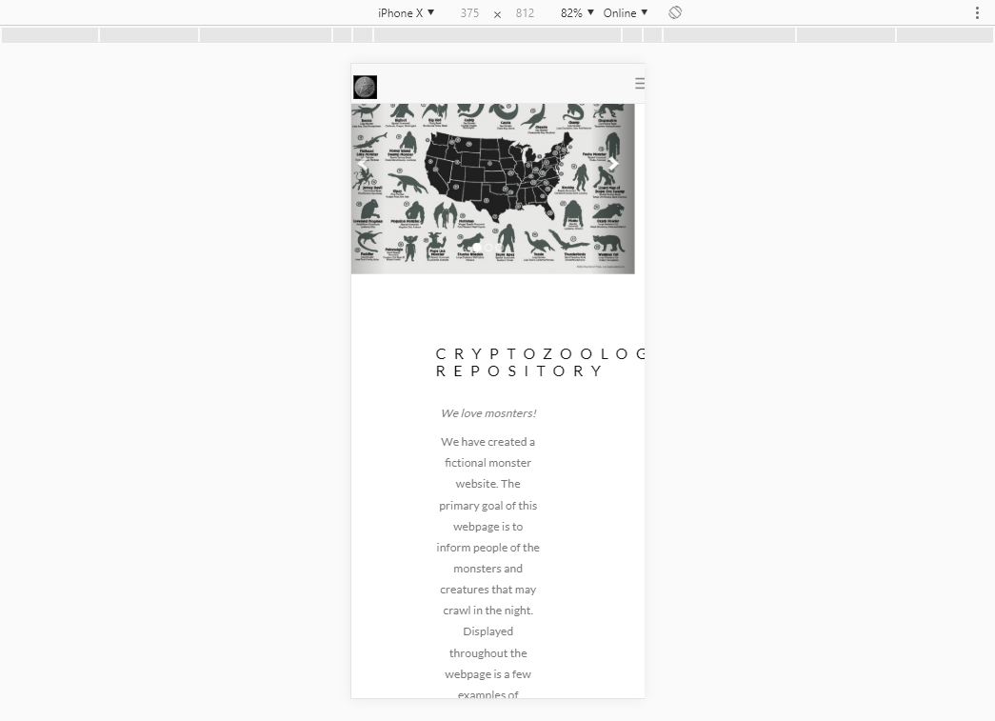

3.1

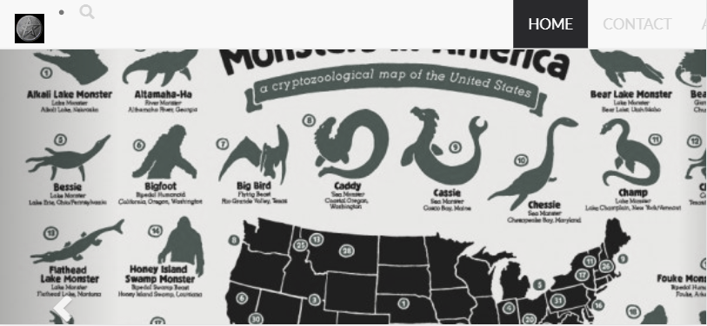

3.2

